**Project 3: Creating a Shell Interface**

Hao Wu

5140219226

May 16, 2017

Instructor: Ling Gong

1. Object:

Write a program that can imitate a simple shell and execute some basic commands. You can see the detail in the end of chapter 3 of OPERATING SYSTEM CONCEPTS WITH JAVA(Seventh Edition), page 127..

1. Screen Cut:

This project can basically realize the function of shell, like cd, ls, pwd, history, !, !!, etc. As shown below, we can use ls –al to observe the information of the files and directories in this space, and by typing in cd .. to get to the up level. By using history, we can see the command we typed in before, and use ! and !! to invoke these commands.

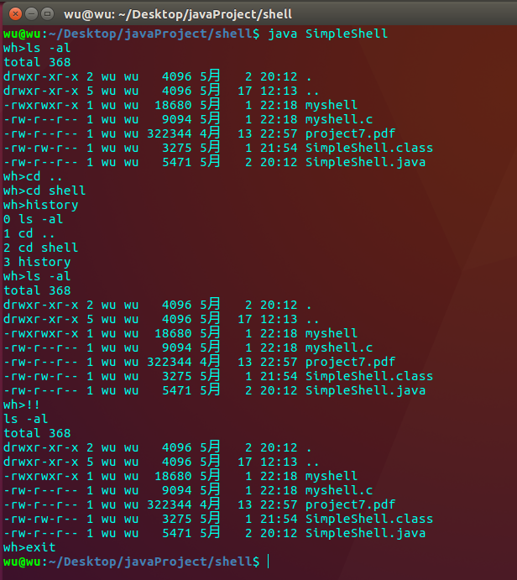

**Fig1 Simple shell interface**